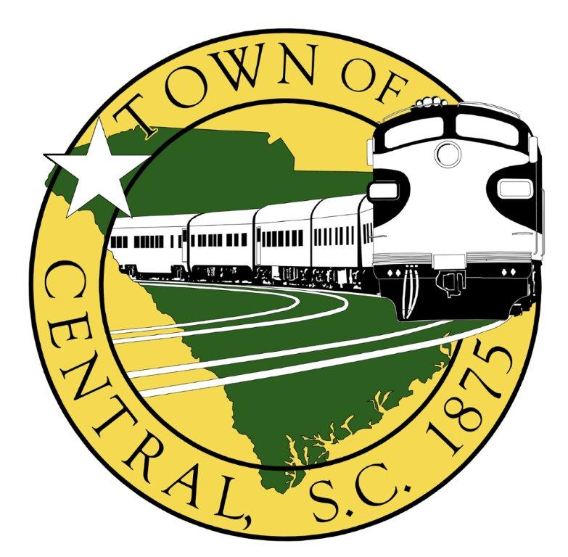

CENTRAL COMMUNITY PARK BUILDING RENTAL

, has rented the Central Community Park Building for:
(Name and contact phone #)
____ .
(Day of Week) (Date)
Inspection Checklist:
- Have floors been swept and are they clean? Yes No
- Are bathrooms clean, toilets flushed, and faucets turned off? Yes No
Notes:
- Have tables, chairs, kitchen sink, countertops, oven, stove, & refrigerator been wiped down?
Yes No Notes:
- Was the oven, stove, & exhaust fan turned off, and was the oven & refrigerator free of any leftover food?
Yes No Notes:
- Was the entire building clear of trash and was the trash disposed of properly in the outside trashcans?
Yes No Notes:
- Were the front and back doors locked?
Yes No Notes:
- Were the lights and heating/air unit turned off? Yes No
Notes:
- Note any damage, if found:
Inspection by: Date:
I understand no fires are allowed in the fireplace, and the tables are not to be moved in order to prevent damage of floor tile. I have read the inspection checklist above & understand that in order to receive my $50 deposit, the building must pass the inspection above, and if any keys are issued, all keys must be returned to Town Hall within three working days of using the park. If you cancel the building rental at any time, you forfeit your $50 deposit.

Mailing Address –PLEASE PRINT

Signature of Person Renting the Building Date

Non-refundable Reservation fee of $50 and Rental fee of $125.00 has been paid.
Receipted by:
If issued, have keys been returned? Yes
(Date)
FORM ON BACK MUST BE COMPLETED

HOLD HARMLESS AGREEMENT

, its officers, employees, and members shall, through the signing of this Agreement by an authorized party or agent, indemnify, hold harmless and defend the Town of Central and its agents and employees from all suits and actions, including reasonable attorneys’ fees and all costs of litigation and judgment of every name and description against the Town as a result of loss, damage, or injury to a person or property by reasons or any action or omission by , its agents, or employees for the following activities:

Instructions for Opening Community Park Building
To Unlock:
Press the SCHLAGE button at the top
Enter Code
Turn knob to the right

To Lock:
Press SCHLAGE button
Turn knob to the left
Check to see that the door is locked

*If the keypad fails to work, call the Central Police Department at 864-639-4020 and they can come unlock the building.

Key Code #:

Signed this day of , 20 .
By:
Title:

